 |  | TERMO DE ACEITE TÉCNICO
Solicitante: VIVO- Projeto Escolas Rurais
NOC/Operador: Bruno Carvalho de Sá |  |  | Cliente: VIVO
Empresa  EMC Brasil | VSAT-ID  VIVO-PER-23178558-CE |  | Link kbps  256/128 | Plataforma  VSAT
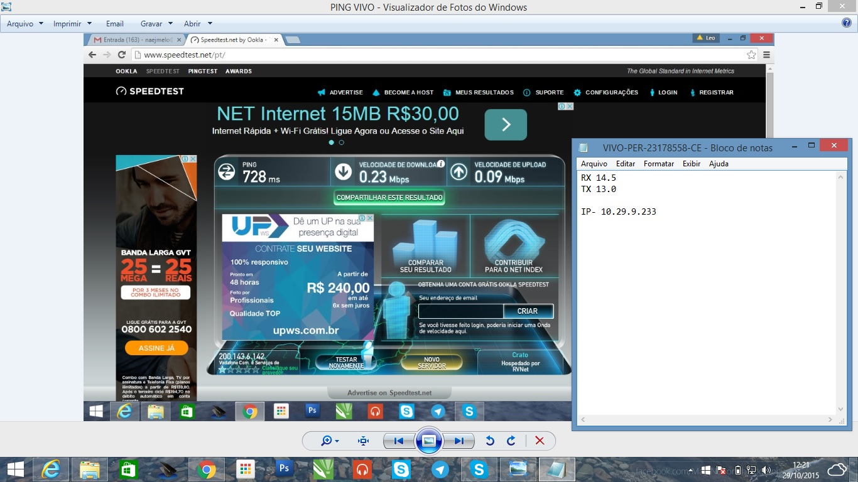

Satellite (DVB) TX Configuration
--------------------------------
Auto start : Enabled
IDU Output Power : -20 dBm
IDU Max Output Power: 0.0 dBm
ODU Output Power : 35.2 dBm
EIRP : 48.5 dBW
Default CW Frequency: 0.000000 GHz
ATM mode : VC-Mux
Header Compression : None

Satellite (DVB) Transmitter Status
--------------------------------
State : On (TDMA)
IDU Output Power : -19.5 dBm
ODU Output Power : 34.5 dBm
EIRP : 47.8 dBW
Eb/No : 10.5 dB
Header Compression : Disabled
Timing correction : -283 us (261128 us)
Frequency correction: -250 Hz
# dvb tx show

Satellite (DVB) TX Configuration
--------------------------------
Auto start : Enabled
IDU Output Power : -20 dBm
IDU Max Output Power: 0.0 dBm
ODU Output Power : 35.2 dBm
EIRP : 48.5 dBW
Default CW Frequency: 0.000000 GHz
ATM mode : VC-Mux
Header Compression : None

Satellite (DVB) Transmitter Status
--------------------------------
State : On (TDMA)
IDU Output Power : -19.5 dBm
ODU Output Power : 34.7 dBm
EIRP : 48.0 dBW
Eb/No : 12.5 dB
Header Compression : Disabled
Timing correction : -283 us (261128 us)
Frequency correction: -250 Hz
# dvb rx show

Satellite (DVB) RX Configuration
--------------------------------
Auto start : Enabled
Max MODCOD : 23 16APSK-9/10 (SNR threshold: 23.5 dB)
RX watchdog : 15 minute

Idx Pri SymbRate[Msps] Freq[GHz] Mode PopId Enable
* 0 0 9.320000 12.055825 DVB-S2 4 Yes
1 1 0.000000 0.000000 DVB-S2 2 Yes

Satellite (DVB) Receiver Status
--------------------------------
Rx State : On
DVB State : Forward link up
Network : 1326, GlobalIP@Telstar-14R
Frequency : 12.055483 GHz
Symbol Rate : 9.320016 Msps
S2 ModCod
- receiving : 16 8PSK-8/9
- current max : 23 16APSK-9/10
Pilot : On
Frame length : Short
DVB S2 Mode : ACM
Roll off : 0.25
SNR : 14.3 dB
Input Power : -30 dBm
# ping 8.8.8.8
64 bytes from 8.8.8.8: time=560 ms
64 bytes from 8.8.8.8: time=580 ms
64 bytes from 8.8.8.8: time=620 ms
64 bytes from 8.8.8.8: time=840 ms
64 bytes from 8.8.8.8: time=540 ms

--- 8.8.8.8 ping statistics ---
5 packets transmitted, 5 received, 0.00 percent packet loss
rtt min/avg/max = 540/620/840 ms
#

